**Aim**

To design and deploy a **Flight Reservation System** as a **cloud-based SaaS application** using a cloud service provider (Zoho Creator), where users can search for flights, book tickets, and manage reservations.

**Procedure**

**Step 1: Login to Cloud Provider**

* Open Zoho Creator and sign in with your Zoho account.

**Step 2: Create a New Application**

* Click **Create Application → From Scratch**.
* Name it: **Flight Reservation System**.

**Step 3: Build Forms (Data Entry)**

1. **Flight Details Form**
   * Flight Number (Text)
   * Airline Name (Text)
   * Source Airport (Dropdown/Text)
   * Destination Airport (Dropdown/Text)
   * Date (Date Picker)
   * Departure Time (Time Picker)
   * Arrival Time (Time Picker)
   * Available Seats (Number)
2. **Passenger Booking Form**
   * Passenger Name (Text)
   * Email (Email)
   * Phone Number (Phone)
   * Flight (Lookup from Flight Details Form)
   * Number of Seats (Number)

**Step 4: Create Reports (Data Views)**

* **Available Flights Report** → List all flights with available seats.
* **Booking Report** → Show passenger reservations.
* Apply filters so passengers can search by Source, Destination, and Date.

**Step 5: Add Workflow (Automation with Deluge Script)**

* When a booking is made:
  + Reduce the number of available seats in the selected flight.
  + Send a confirmation email to the passenger.

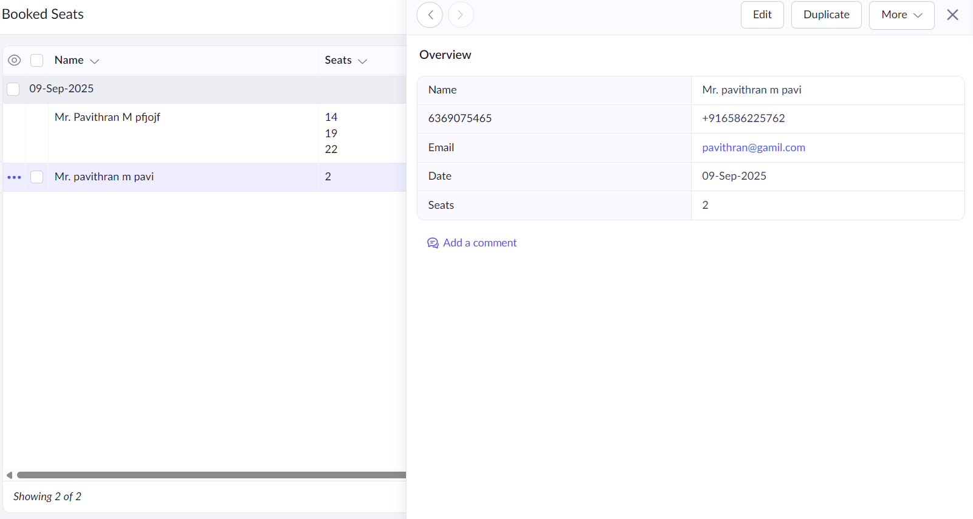

**Result**

* A **Flight Reservation SaaS Application** was successfully created and deployed using **Zoho Creator**.
* Passengers can search flights, book seats, and receive booking confirmations.
* The app automatically updates seat availability.
* The system is hosted on Zoho’s cloud and accessible worldwide via a web link, demonstrating **Software as a Service (SaaS)**.